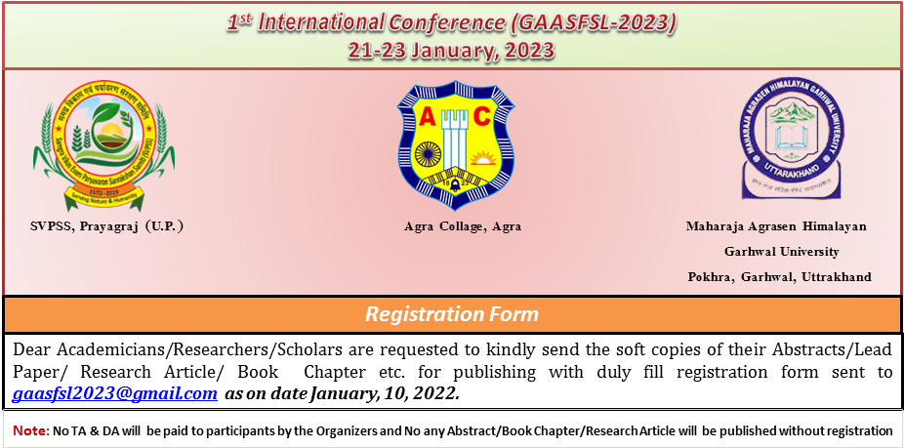

- Correspondence Email:
- Contact &WhatsApp No.:
- Gender (M / F):
- Name in Capital (Prof. / Dr. /Mr. /Ms.):
- Designation:
- Subject:
- Department:
- Organization:
- Correspondence Address:
- Participation Type: A-Oral Presentation B- Poster Presentation C- None
- Submitted Manuscript:
- Abstract
- Poster
- Lead Paper for Proceeding Book
- Research Paper for Journal
- Book Chapter for Edited Book
- If you interested for Presentation, please send following details:
A- Date & Session
B- Presentation Title

- Accommodation: (on Payment Basis)
- Yes / No
- Basic Hotel / Deluxe Hotel / Super Deluxe Hotel / Hostel/ Dormitory
- No. of Accompanying Person
- Conference Registration Fee:
- Rs. in Words:
- Payment Mode (NEFT/RTGS/Net Banking/PayTm/GPay/PhonePe/PayPal/Other):
- Payment Date: Transaction Reference Number:

- Sign &Date:

DetailsforConference Fee
Banking Account Details |  | Online Payment Details
AccountName | Samagra Vikash Evam Paryavaran Sanrakshan Samiti | PayTm/Google Pay/  PhonePe | 9587263545
Bank Name | Indian Overseas Bank
Bank Address | Mahewa Poorav Patti, Prayagraj,U.P.,India
Account No.  IFSC Code:- | 255602000000190  IOBA0002556
IFSCCode | IOBA0002556
 |  | PayPal

