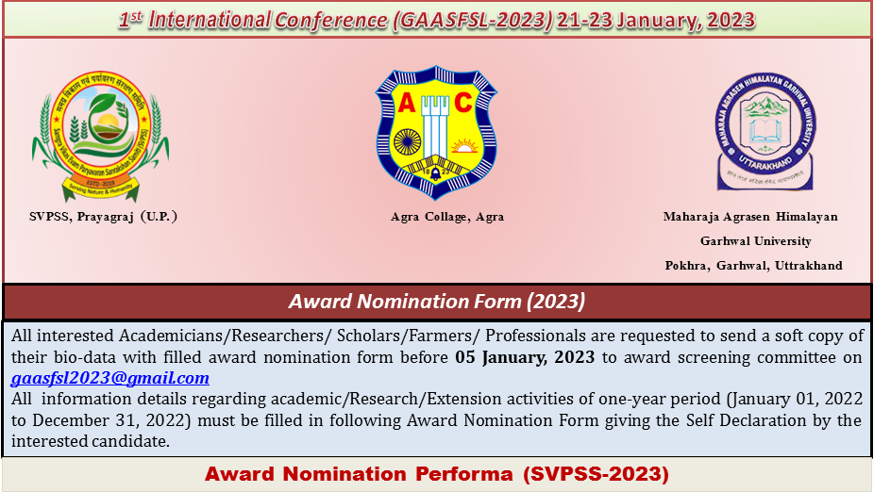
- Award Name:
Recent Photo

- Corresponding Email:
- Contact &WhatsApp No.:
- SVPSS Lifetime Member (Yes/No) If Yes (Membership No):
- Title Name (Prof. / Dr. / Mr. / Ms.):
- Name (In Capital):
- Present Designation:
- Department:
- Organization:
- Subject (For Award):
- DOB:
- Gender (M/F)
- Nationality
15. Academic/Research/ Extension Details (01 Jan, 2022 to 31 Dec, 2022)
- No. of Research Papers B. No. of Popular Article C. No. of Book Chapters D. No. of Written Book
E. Any other Publication F. Any Outstanding Achievement
16. Any Award / Fellowship as mention period
17. Any other information (if any)
Declaration: I hereby declare that the information given in this form is true and correct to the best of my knowledge and belief.

Place: Date: Name: Sign:
Note: Award nomination fee is mandatory for award (Delegates/Scientist/Academicians/Professionals: INR 2100/- Two thousand one hundred rupees only all other previous lifetime members of the SVPSS Society if apply for any award please pay award nomination fee is INR 1000/- One Thousand Rupees only and no any fee for Innovative Farmer Award.
DetailsforConference Fee
Banking Account Details |  | Online Payment Details
AccountName | Samagra Vikash Evam Paryavaran Sanrakshan Samiti | PayTm/Google Pay/  PhonePe | 9587263545
Bank Name | Indian Overseas Bank
Bank Address | Mahewa Poorav Patti, Prayagraj,U.P.,India
Account No.  IFSC Code:- | 255602000000190  IOBA0002556
IFSCCode | IOBA0002556
 |  | PayPal

DetailsforConference Fee
Banking Account Details |  | Online Payment Details
AccountName | AgriculturalTechnologyDevelopment Society | PayTm/Google Pay/  PhonePe | ATDSAccount Number  or  9760478520  7017720161
Bank Name | CanaraBank
BankAddress | Muradnagar,Ghaziabad,U.P.,India
AccountNo. | 3766101002135
IFSCCode | CNRB0003766
MICRCode | 110015207 | PayPal | paypal.me/atds2016

